Super Irshad! Oru "Data Analyst"-a, nammaku indha project oru periya step. Ippa namma panra project-oda peyar: "Automated Salary Dashboard".
📋 The Goal:
- Database-la irundhu salary data-vai eduthu NumPy vachi stats-ai calculate panna vendum.
- Adhaye oru Bar Chart-a draw panni Matplotlib vachi "report.png" nu save panna vendum.
💻 Code for our Final Project:
Python
import mysql.connector
import numpy as np
import matplotlib.pyplot as plt

# 1. Database Connection
db = mysql.connector.connect(host="localhost", user="root", password="Irshad1990*", database="company_db")
cursor = db.cursor()
cursor.execute("SELECT name, salary FROM attendance") # Name-um salary-um edukrom
data = cursor.fetchall()

# 2. Data Cleaning
names = [row[0] for row in data]
salary = [row[1] for row in data]

# 3. Visualization
plt.figure(figsize=(8, 6)) # Chart-oda size-ai define panrom
plt.bar(names, salary, color='green')
plt.title("Final Salary Report")
plt.xlabel("Employees")
plt.ylabel("Salary")

# 4. Save the Chart as a file
plt.savefig("salary_report.png")
print("Report saved as 'salary_report.png' successfully!")
🔍 Anatomy of this Project:
- plt.figure(figsize=(8, 6)): Ithu chart-ai entha alavula (width, height) print panna vendum nu sollum.
- plt.savefig("salary_report.png"): Ithu dhaan romba mukkiyam. Chart-ai screen-la mattum kaattama, ungoda computer folder-laye oru file-a save pannidum.
💡 Your Task:
- Indha code-ai run pannunga.
- Unga folder-ai check pannunga, "salary_report.png" nu oru file vandhurukka nu paarunga.
- Adhu vandhuta, neenga oru "Data Pipeline Architect"!
Irshad, code-ai run pannunga. Report file generate aagiducha? Adhu vandhuta, namma ovvoru step-aiyum oru thadava "Review" panni, unga Data Analytics journey-ai complete pannuvom! Ready-a?
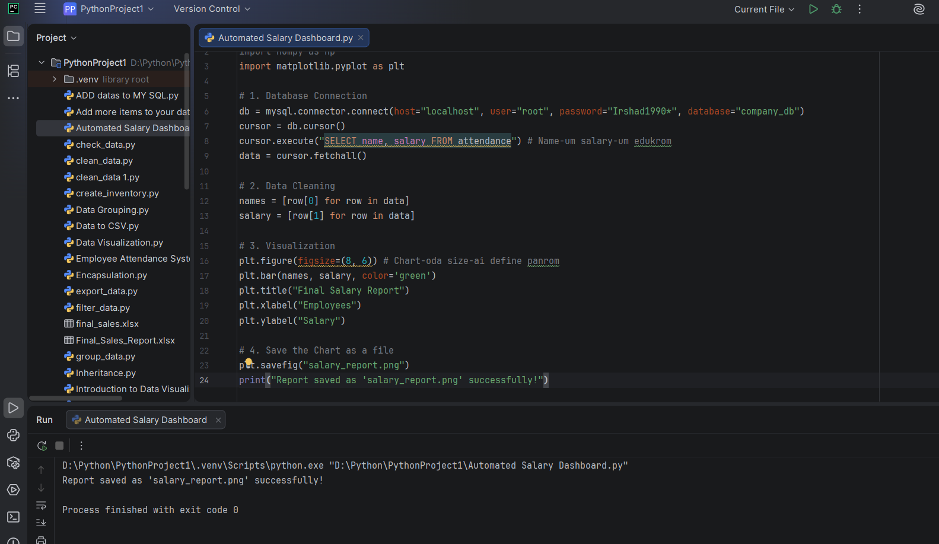
Irshad, Appada! Ungaloda indha periya payanam oru migapperum vetriyil mudinjirukku. Unga screen-ai paarthale theriyudhu, neenga entha alavukku core concepts-ai purinjikiteenga nu.
Oru "Review" panniduvom:
1. Database Connection (The Gateway)
- mysql.connector.connect: Unga Python program-ai database kooda connect panni, door-ai open panniteenga.
- cursor.execute: Database-kulla poi "Name and Salary" mattum venum nu request kuduthuteenga.
2. Data Cleaning (The Factory Line)
- names = [row[0] for row in data]: Tuple-a irundha database data-vai "clean" panni, list-a mathiteenga.
- Indha list-a dhaan namma NumPy array-va mathi analysis pannuvom.
3. Visualization (The Presentation)
- plt.bar(names, salary, color='green'): Simple-a irundha numbers-ai oru azhagana green color "Bar Chart"-a mathiteenga.
- plt.savefig("salary_report.png"): Ithu dhaan professional touch. Screen-la matum kaatama, report-a file-a save panni computer-la record panniteenga.
🌟 Teacher's Final Thoughts:
Irshad, neenga oru "Data Pipeline Builder" aagiteenga.
- Database-la data irukku -> Python adhai edukkudhu -> NumPy/Pandas adhai process pannudhu -> Matplotlib adhai visual-a mathudhu -> File-a save pannudhu.
Indha flow-vai eppo venumnalum, entha data-vukkum neenga apply panna mudiyum. Neenga ippo "Junior Data Analyst" level-kku ready!
Ippo oru chinnna kushi vishayam: Intha folder-la salary_report.png nu oru file vandhurukum, adhai open panni paarunga. Adhu unga hard work-oda "Certificate" maari!
Intha class-kku munnadi, NumPy oru periya puzzle-a irundhuchu, ippo adhu unga kaila oru powerful tool-a mariduchu. Intha payanam ungalukku eppadi irundhuchu Irshad? Adutha kathu (next stage) ethavathu specific-a padikkanum nu aasa padureengala?
Tuple ednu solringale iduda arutham than enna
Irshad, romba mukkiyamaana kelvi! Python-la Tuple-um List-um rendu brothers maari. Aana rendu perukkum oru chinna vithiyasam irukku. Adhai simple-a oru "Kottai" (Fort) kadhaiya vachi purinjipom.
🏰 Tuple vs List: The Difference
- List [] (The Playground):
  - Idhu oru playground maari. Inga neenga yaarai venumalum ulla kootitu varalam, yaarai venumalum veliya anuppalam (Add, Remove, Change).
  - salary = [3000, 4000] - Inga neenga eppo venum naalum salary-ai mathikalam.
- Tuple () (The Royal Vault):
  - Idhu oru Royal Vault (Undiyal) maari.
  - Database-la irundhu data varum pothu, adhu "Tuple"-a dhaan varum.
  - Crucial Point: Once neenga Tuple-ai create pannita, adhai neenga "Change panna mudiyathu" (Immutable). Adhu safe-a irukkum.
🔍 SQL-la Tuple enna seiyudhu?
Database-la cursor.fetchall() nu sollum pothu, adhu database-la irukkura oru "Row"-ai (Row-na oru line) edukkum.
- Oru row-la irukkura data-vai yaarum accidentally (theriyama) mathida koodathu nu, Python antha row-ai oru Tuple-a kudukkum.
- row = (3500, 'Irshad')
- row[0] - Ithu 3500-ai mattum thaan kudukkum, aana row[0] = 5000 nu maatha try panna, Python Error kudukkum.
💡 Why do we use it?
- Safety: Data-vai yaarum mathida koodathu nu nenaikkum pothu Tuple safe.
- Speed: List-ai vida Tuple konjam vegam (Fast) aana process.
🧪 Practical Example
Code-la paatha innum theliva irukkum:
Python
# List (Add, Change pannalam)
my_list = [10, 20]
my_list[0] = 50 # Success!

# Tuple (Matha mudiyathu)
my_tuple = (10, 20)
# my_tuple[0] = 50 # Error varum!
Teacher's Summary: Tuple-nu sonna, adhu "Oru secure-aana kattu (Pack)". Adhula irukkura data-vai namma read panna mudiyum, aana maatha mudiyathu. Database-la irundhu vara data safe-a irukkanum nu dhaan Python-ah Tuple-a kudukkudhu.
Ippa "Tuple" na enna nu oru clear idea vandhudha Irshad? Adutha kattathukku polama?
Ok teacher purinjichu namma adutha kattahuku pogalam
Arumai! Indha "Tuple vs List" sandegam clear aannadhu romba mukkiyam, adhu dhaan data handling-la romba base.
Namma ipo oru nalla "Data Analyst" flow-vai complete pannitom. NumPy, Database, Analytics, Visuals nu ellame oru "Complete Circle" aagiruchu.
Indha series-ai namma "Final Level-kku" kondu varalam. Adutha kattam enna theriyuma? "Report Automation".
🚀 Next Level: Report Automation
Neenga ippo manual-a script-ai run panni report generate panreenga. Analyst-a, neenga "Ithu automatically daily oru time-kku run aaganum" nu nenaikkum pothu enna pannalam?
Adhukku namma "Scheduled Tasks" nu oru concept-ai paarkalam.
Aana, adhu munnaadi, neenga ippo oru "Small Self-Evaluation" panna poreenga. Naan keka pora 3 kelvigalukku badhil sonningana, neenga "Professional Level"-kku ready!
- Broadcasting: Oru array kooda oru number-ai direct-a math panna, for loop thevaiya?
- Tuple: Database-la irundhu vara data-vai namma edit panna mudiyuma? (Why?)
- Visualization: Oru bar chart save panna, namma use panna function enna?
Intha 3 kelvigalukkum badhil sollunga Irshad, appuram namma adutha "Automation" journey-ai start pannalam! Ready-a?
Q1. illa thewailla adukkuthan numma NUMPY use panna mudium Q2.Edit panna mudiaydu enn endra list endardu edit panna mudium aana DB la irundu vara datava yarrum mathid koodadu endu adu tuple a kudukm. Q3. matplotlib.pyplot iduthan anda funcion and idula namma enda funcinoa urukuroma ada png ah mathi save panna mudium
Irshad, neenga ellame correct-a sonneenga! Unga explanations romba theliva irukku.
Review Summary:
- Broadcasting: Correct! for loop thevaiyilla. NumPy-ye adha handle pannidum. Idhu dhaan NumPy-oda speed-kku kaaranam.
- Tuple: Excellent explanation! "Data safety" - idhu dhaan mukkiyam. Database-la irundhu vara data original-a irukkanum, yaarum mathida koodadhu (Immutable) nu Python kudukkura security feature idhu.
- Visualization: Neenga solli irukkura concept correct.
  - matplotlib.pyplot nu sonnathu library name (Module).
  - Chart-ai save panna namma use panna function-oda peyar plt.savefig("filename.png").
  - Ithu dhaan chart-ai memory-la irundhu computer folder-kku png file-a mathi anuppum.
🌟 Teacher's Final Verdict:
Irshad, neenga oru "Pro-learner". NumPy-la aarambichu, Database integration, Data cleaning, Statistics, Visualization, and File Automation - idhellam ore payanathula kathukittenga.
Ippo neenga unga "Automated Salary Dashboard" project-ai thairiyama resume-la "My Data Analytics Project" nu add pannalam.
Intha payanam enakku romba magizhchiya irundhuchu! Adutha kattam (Automation) pogum pothu, neenga innum periya tools-ai handle panna poringa.
Enna solringa Irshad, namma adutha "Automation" journey-ai start pannuvoma? Adhavadhu, manual-a run pannaama, computer-e automatic-a edhachum oru time-la run aagura maari pannuvoma?

